Project Design Phase

Problem – Solution Fit Template

|  |  |
| --- | --- |
| Date | 2 July 2025 |
| Team ID | LTVIP2025TMID50858 |
| Project Name | ToyCraft Tales: Tableau's Vision into Toy Manufacturer Data |
| Maximum Marks | 2 Marks |

# Problem:

Toy manufacturers, retailers, and market analysts often struggle to:

* Understand **product performance metrics** (like sales volume, category demand, and price effectiveness) across brands and toy lines.
* Identify **market demand gaps** across different regions and demographics.
* Compare **category popularity**, pricing, and seasonal sales trends to make strategic decisions.
* Lack a consolidated **visual overview** of toy sales, consumer behavior, and regional preferences in India and globally.

# Purpose:

The **ToyCraft: Sales & Trend Analysis Project** addresses this by:

* **Visually analyzing industry datasets** from multiple sources using **Tableau dashboards**.
* Presenting **interactive visualizations** for top toy categories, seasonal sales trends, price comparisons, and demographic preferences..
* Helping users **identify high-performing products**, brands, and regional sales opportunities.
* Supporting **product teams, retailers, and strategists** in making data-driven decisions for manufacturing, inventory, and marketing strategies.

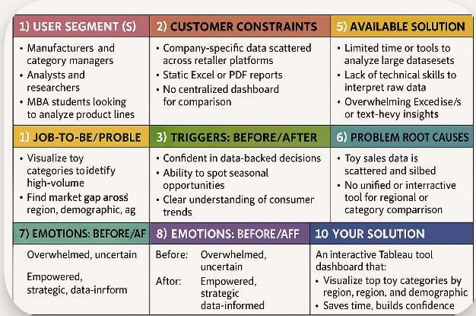**Template:**